Given a matrix A, return the transpose of A.

The transpose of a matrix is the matrix flipped over it's main diagonal, switching the row and column indices of the matrix.

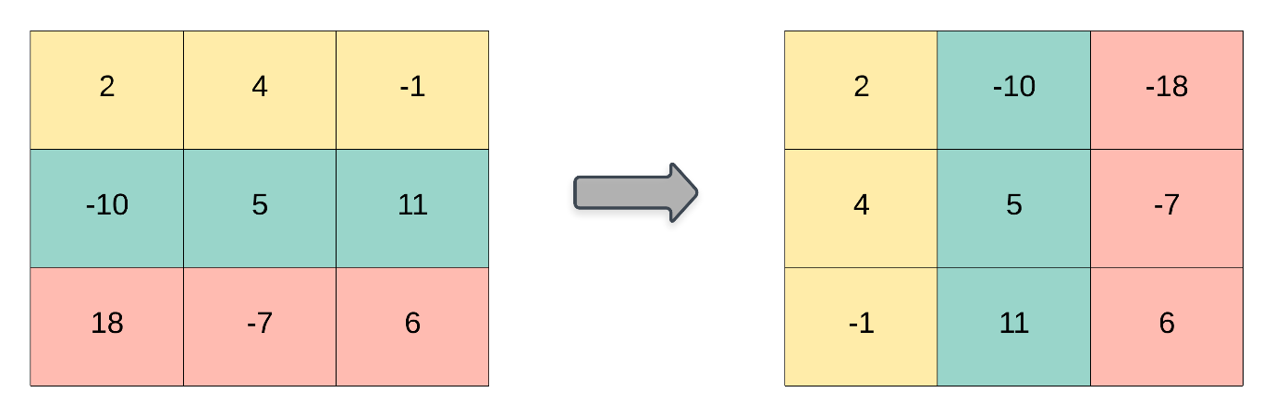

**Example 1:**

**Input:** [[1,2,3],[4,5,6],[7,8,9]]

**Output:** [[1,4,7],[2,5,8],[3,6,9]]

**Example 2:**

**Input:** [[1,2,3],[4,5,6]]

**Output:** [[1,4],[2,5],[3,6]]

**Note:**

1. 1 <= A.length <= 1000
2. 1 <= A[0].length <= 1000